**TITLE PAGE**

**BANO QABIL 2.O PROGRAM**

**MID TERM ASSIGNMENT**

WEBSITE NAME: PAKISTAN TRAVEL

GROUP NAME: MASTERMIND

PROJECT NAME: WEBSITE DEVELOPMENT

STUDENTS NAME: IFFAT UL FATIMA & KHADIJA NIZAM

STUDENTS ID: WD1-F-34553 &

WD1-F-119958

BATCH CODE: 1605

TEACHER NAME: SUMBUL SALEEM

CLASS NAME: WEB DEVELOPMENT-I

CENTER NAME: PAKISTAN CENTRAL HOMEOPATHIC COLLEGE



WEBSITE:

A website is a unique way to connect with the world. I created my website to show beautiful sights of Pakistan.It is also a part of my assignment,which I am learning from Bano Qabil.

In this website we use HTML & CSS to create our website.We use different tags like linking tags to link our pages e.g index,about,service & contact pages,image tag for image,center,bold,italic,color,background-color etc to create this beautiful website.

PAKISTAN TRAVEL WEBSITE:s

Pakistan’s awe-inspiring destinations should be visited with a hike of charm and excitement. Pakistan is enriched with the vast mountain ranges for trekkers, adventure lovers and relaxing views for the calm personalities, however, Northern Pakistan is particularly called the enduring region worldwide. Breathtaking peaks, scenic lakes, whistling springs, lush green meadows, archaeological and historical sites, there are many more to make rejoice your travel expedition.

ABOUT US:

Pakistan Travel Places is one of the best and reliable tourism company in Pakistan. To get into the traveling expedition, you’ve just got the right option. We take you higher to explore the surprising beauty of Pakistan. As a Pakistan tourism company, we introduced the best opportunities to travel with enticing and super-comfy services. So, get ready for a journey that you’ve never seen before!

Do not worry if you’re confused to find the trustworthy Travel agency in Lahore, Pakistan. You can see our client’s review, we are completely different from other traveling firms. People trust on our services blindly and spreading our tour company to others.

We arrange a fully entertaining and exploratory journey to your desired destinations. Whether you look forward to getting around all the tourist spots of booked place or even want to focus its highlights to make the tour brief and rejoicing, every client with multiple travel priorities is welcomed at Pakistan Travel Places.

SERVICES/View All Services

Pakistan, where your journey begins.

Discover your next great place, find trips and know about the famous travel destinations of Pakistan.

A travel and tourism company of Pakistan, city sightseeing, group and corporate tours, camping and hiking adventures, family and solo trips, and much more for a perfect travel experience in Pakistan!

OUR RECENT TOURS:

Pakistan is a very blessed country as it has high rising mountains, vast rivers, lakes, waterfalls, and much more. We offer you to travel the northern areas of Pakistan with Pakistan Travel Places and witness the beauty that God has bestowed upon Pakistan. Here is the gallery of our recent tours to the northern areas of Pakistan.

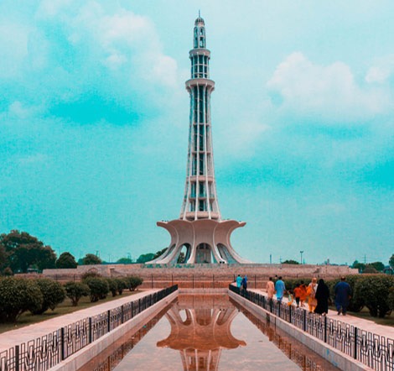



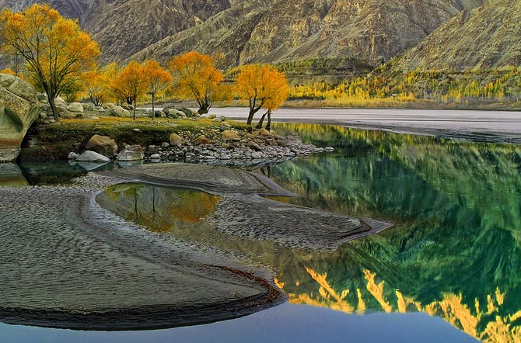

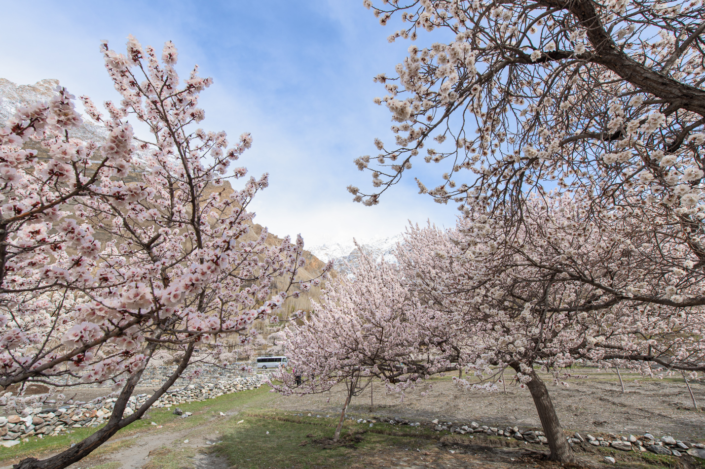

In this website we offer some travelling packages:

Check Tour Packages according to popular destinations of Pakistan and confirm your booking at our website.

CLASS OVERVIEW:

The curriculum is well balanced and provides the learners the opportunity to thrive and become independent learners and thinkers and developer. Work in small group settings and provide differentiated instruction and individual approach, to meet our needs. We learn through lectures, hands on activities, and we consider learning as an adventure where many brains work together to create, discover and question the facts of life and the world around us.

I am very pleased with this format. The instructor was very knowledgeable, worked at a good pace, and most importantly, was very good at communicating with all the attendees and ensuring questions were answered.Our instructor was an expert and was very clear in his method of teaching. All my questions were answered and the class interaction was very good. I would take another course with BANO QABIL and I would definitely recommend BANO QABIL to others and I hope to have the opportunity to attend more training classes with BANO QABIL."

THANK YOU